Step 1: Set Up Environment
Before you start migrating the files, make sure you have the following set up:
1.1. Veeva Vault API Access
- access to the Veeva Vault CRM API with proper permissions for file staging (uploading files, creating folders).
- Obtain Veeva Vault Session ID (API Authentication Token) to interact with the Vault API.
1.2. SharePoint API Access
- Ensure to have access to the SharePoint environment.
- may need OAuth credentials or a personal access token to access SharePoint resources.
- Ensure that the files want to migrate are accessible for reading from SharePoint (through Microsoft Graph API or SharePoint REST API).

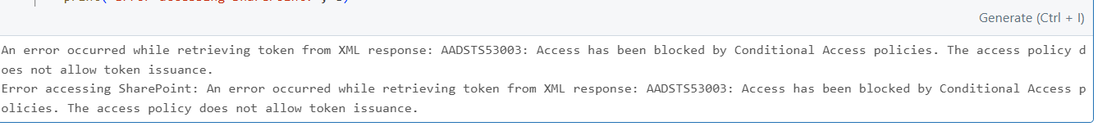

Azure Active Directory (AAD) has blocked the authentication request due to a Conditional Access (CA) policy.
1.3. Databricks Setup
- Set up a Databricks cluster where will perform the necessary transformations or mapping.
- Install necessary Python libraries (requests, Office365-REST-Python-Client, etc.) in Databricks.
Step 2: Download Files from SharePoint
we’ll need to download the files from SharePoint to Databricks. can either download them directly or process them in chunks.
2.1. Use SharePoint API to List Files
can use the Microsoft Graph API or SharePoint REST API to list the files want to migrate. For the Office365-REST-Python-Client library, follow these steps:
- Authenticate with SharePoint credentials.
- List files from a SharePoint directory.
2.2. Download Files to Databricks
- Once listed the files, download each file using the SharePoint URL or the Graph API.

Step 3: Perform Transformation or Mapping in Databricks
Since you’re working with PDF files, transformation might not be necessary unless you need to extract specific data or metadata from the PDFs (like text, tables, or images).
3.1. Extract Text (Optional)
If need to extract text from the PDFs for any transformation or metadata mapping, we can try libraries like PyPDF2 or pdfplumber in Databricks.
Step 4: Upload PDF Files to Veeva Vault staging area
Now that we have the PDF files downloaded, we need to upload them to Veeva Vault staging area. The Veeva Vault File Staging API allows us to upload files to specific folders. Here's how to do it:
4.1. Create Folder in Vault (if needed)
Before uploading the PDF files, you might want to create a folder in Veeva Vault.
4.2. Upload PDF Files
To upload the PDF files, use the Veeva Vault File Staging API. You can use the POST request to upload the PDF file to the folder in Vault.

4.3 using vault loader api upload documents to veeva crm from vault staging area

